**Upload Image To IBM Container**

**Date** 14November 2022

**Team ID** PNT2022TMID47995

**Project Name** Smart Fashion Recommender Application

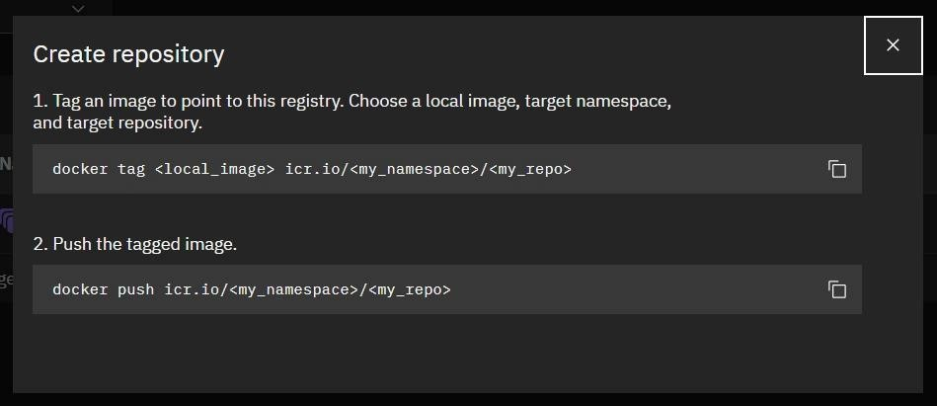

**CREATING REPOSITORY IN IBM CLOUD:**

**UPLOAD IMAGE TO IBM CONTAINER REGISTRY:**

